Assignment: IP Routing and Routing Protocols

1. Network Diagram
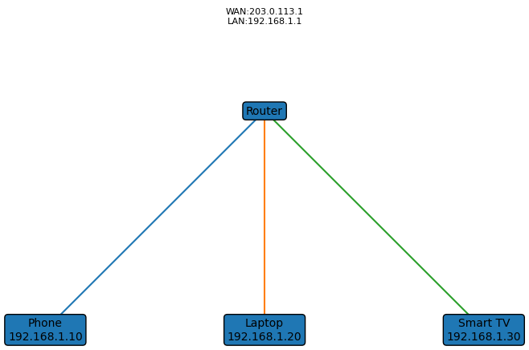

2. Manual IP Routing
Laptop 192.168.1.20 sends a packet to Friend PC 192.168.2.50. It checks its routing table, finds the default gateway 192.168.1.1, sends the frame to Router R1, which checks its routing table and forwards the packet to Router R2 via 10.0.0.2. Router R2 has a directly connected route to 192.168.2.0/24 and delivers the packet to 192.168.2.50.

3. Zomato Routing Table
Network | Mask | Next Hop | Interface
10.1.0.0 | 255.255.255.0 | 10.0.0.2 | G0/0
10.2.0.0 | 255.255.255.0 | 10.0.0.3 | G0/1
10.3.0.0 | 255.255.255.0 | Direct | G0/2

4. Static vs Dynamic Routing
Static Pros: simple, secure, predictable.
Static Cons: manual updates, poor scalability, not fault tolerant.
Dynamic Pros: automatic updates, scalable, adapts to failures.
Dynamic Cons: more CPU/RAM, complex, protocol overhead.

5. Sample OSPF Configuration
router ospf 1
network 192.168.1.0 0.0.0.255 area 0
network 10.0.0.0 0.0.0.3 area 0
Explanation: Enables OSPF process 1 and advertises the listed networks in Area 0.

